**How to change FileShare Witness(Quorum) in Windows Failover Cluster**

1. Logon to Server and Launch Failover Cluster Manager i.e, Run>cluadmin.msc
2. Click on More Actions> 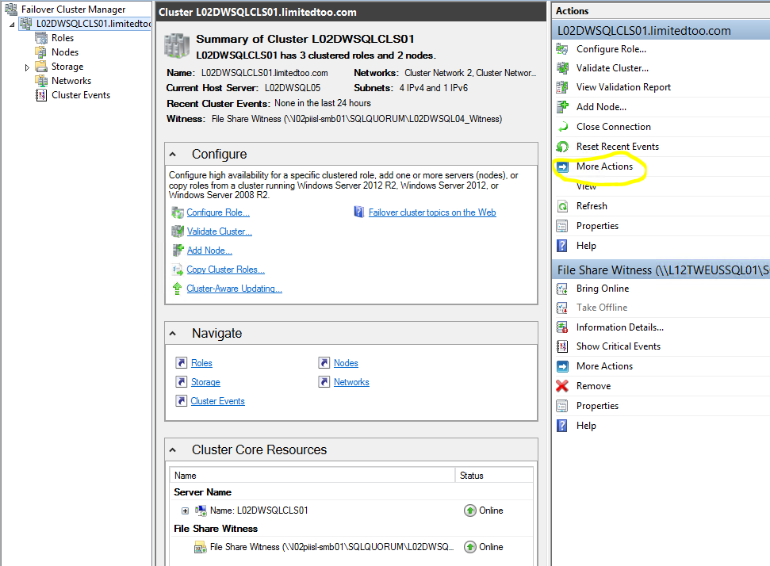
3. And select Configure Cluster Quorum Settings…

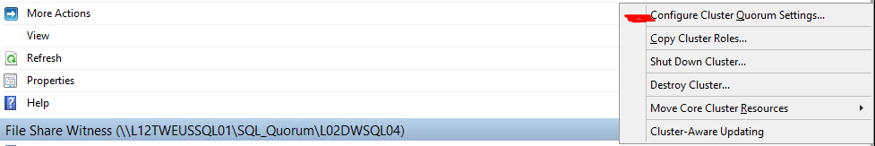

1. It opens up Configure Cluster Quorum wizard and click next to reach below page 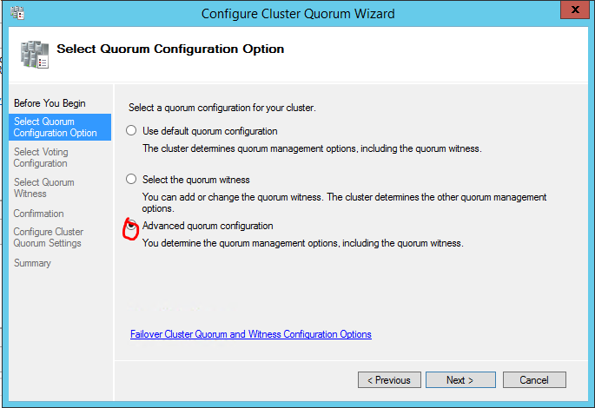
2. Now select Advance quorum configuration and click next.

Select **Nodes** and Click Next to reach below page.

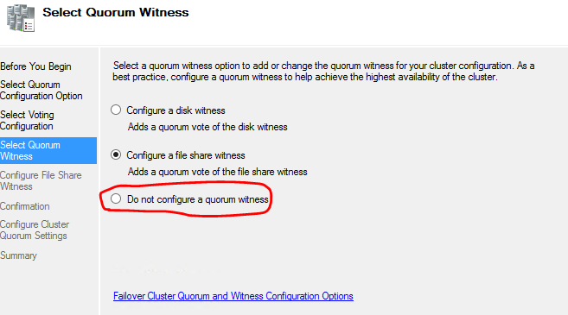

1. Now Select last option and click Next, Now confirm and Finish.

Now, Repeat Step 2-4 and in 5th step select **All Nodes** and click Next

1. Now select **Configure a file share witness** and provide the File share path ( Do verify both the Nodes(servername $) and cluster(clustername $) have permission.) and click Next
2. Now it gets validated and click Next on confirm page to successfully configure quorum settings.